Workshop “Einführung in Methoden der modernen Kausalanalyse“

Exercise on “Selection on unobservables: Control functions”

Prof. Dr. Michael Gebel

Data: Socio-economic panel (SOEP) 2007; students’ version; identifying numbers have been removed

Sample: SOEP samples A-F, persons aged 20 to 60 who are employed at the date of the interview in 2007 and who receive a wage; all apprentices/pupils/students excluded

Treatment: college degree (university degree, technical college degree; CASMIN 3ab) versus no college degree (all the remaining education groups; CASMIN1+2); based on retrospective questions about the highest education degree obtained (CASMIN scale)

Outcome: hourly wage

Control variables and potential instrumental/exclusion restrictions variables:
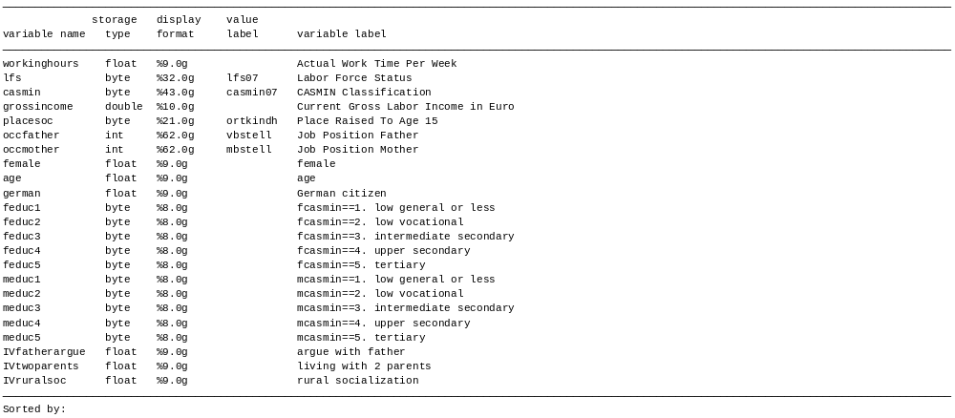
Exercises

Choose the IV “IVruralsoc” for the following exercises and control for age, female, german and father’s education.

1. Estimate a treatment effect selection model without observed heterogeneity in causal effect and without unobserved heterogeneity in causal effect.

2. Estimate a treatment effect selection model with observed heterogeneity in causal effect and without unobserved heterogeneity in causal effect.

3. Estimate a treatment effect selection model with without observed heterogeneity in causal effect and with unobserved heterogeneity in causal effect.

4. Estimate a treatment effect selection model with observed heterogeneity in causal effect and with unobserved heterogeneity in causal effect.

